Mapping Bark Beetle Infestations in the Rocky Mountain National Park from 2014-2016

Hazen Dunphy, Whitney Newcomb, and Joshua Rodriguez

GSP 326 - Fall 2016

Acknowledgements: Buddhika Madurapperuma

## 

## 

## 

## **Abstract**

In the last 10 years, tree mortality has dramatically increased due to the increase in bark beetles. The beetles have destroyed over 70,000 square miles of forest, ranging from New Mexico to British Columbia. This is equivalent to the area of the state of Washington. With higher than average annual temperatures in the winter months and persistent droughts, bark beetle populations are increasing (Lemonick, 2013). The study area of interest was conducted in the Rocky Mountain National Park (RMNP), where there have been historic outbreaks of bark beetles, but none have been as extensive as the most recent (Bark beetles - US Forest Service research & development, 2014).The objective of this project was to determine the impact of bark beetles in the Rocky Mountain National Park from 2014 to 2016. The changes in forest health between the two years were assessed by how many individual trees, or acres of trees that have been impacted by bark beetle infestation. Drought was considered to have been a factor in the possible spread of infestation. To determine the changes between the two years, the following analysis methods were conducted: False Color Composite, Normalized Difference Vegetation Index (NDVI), Normalized Difference Moisture Index (NDMI), and an Unsupervised Classification. Comparing the false color composite images for 2014 and 2016, the 2016 image was determined to have a higher red color density that suggests healthier vegetation in this year. From 2014 to 2016, 2.8% of the park (7374.168 acres) saw an increase in healthy vegetation and 8.5% of the park (22578.41 acres) saw a decrease in NDVI values. However, the NDMI change detection showed there were no areas of increased moisture content but there was a 97.6% decrease in the park (260318.3 acres) over these two years. An unsupervised classification for this analysis was conducted and resulted in 3 dominant classes: (1) clouds, cloud shadows, snow, and water, (2) less photosynthetic activity and conifers, and (3) new vegetation, riparian areas, and shrublands. The difference between the two years for the unsupervised classification may prove to be erroneous because of an ENVI licensing issue to utilize atmospheric correction to provide the true difference between the images. The analysis conducted in this investigation determined that the vegetation density is more abundant in 2016 compared to 2014. Less competition generated by bark beetles provided a higher vegetation density overall in the RMNP region. The drastic change in NDMI may be from seasonal snowpack melt, increasing the available water to vegetation and increasing the NDMI value. Further analysis should be done to accurately determine the impact of bark beetle infestation in RMNP region. This study could also encompass a longer time frame and analyze the existing data for earlier years. For ease of analysis it is recommended that a smaller region of interest be selected for any further study.

## **Introduction**

In the last 10 years, tree mortality has dramatically increased due to the increase in bark beetles. The beetles have destroyed over 70,000 square miles of forest, ranging from New Mexico to British Columbia (Lemonick, 2013). This is equivalent to the area of the state of Washington. As the climate changes, bark beetle populations are increasing. As the temperature of the climate increases and precipitation levels decrease, the range of the beetles move to higher latitudes and higher elevations, affecting tree species that would not normally be affected by bark beetles (Negron, 2015). These beetles are usually vulnerable to cold-induced mortality, but since winter seasons are steadily getting warmer, bark beetles can continue their infestation. Due to the decrease in precipitation, there is an increase in drought, which decreases the trees’ defence mechanisms against beetle attacks (Bentz et al., 2010). All these factors create a positive feedback loop with nothing positive about it.

There are 17 native species of bark beetle that occur in the Rocky Mountain National Park (RMNP). There have been historic outbreaks of bark beetles in the park, but none have been as extensive as the most recent. This could be due to the fact that in the last 10 years, winters in RMNP have been much warmer on average than in the past, as well as the fact that there is a decrease in precipitation in RMNP. The main tree species being affected in RMNP are lodgepole pine, ponderosa pine, limber pine, Engelmann spruce, subalpine fir, and Colorado blue spruce. The main way to reduce these outbreaks without harming the beetles or trees is to take out the hazardous trees. The park fortunately uses these trees on construction projects and to line trails. Another option is to spray an insecticide (Carbaryl) to protect “high value trees,” however this requires spraying chemicals and the RMNP mitigates the amount sprayed as well as the location of spraying (i.e. not near a water source or wetland) (Bark beetles - US Forest Service research & development, 2014).

The objective of this project is to determine the impact of bark beetles in the Rocky Mountain National Park over two years (2014-2016). We will calculate changes in forest health between the two years to assess how much acreage of trees have been impacted by bark beetle infestation. We will also look at how drought may have been a factor in the possible spread of infestation.

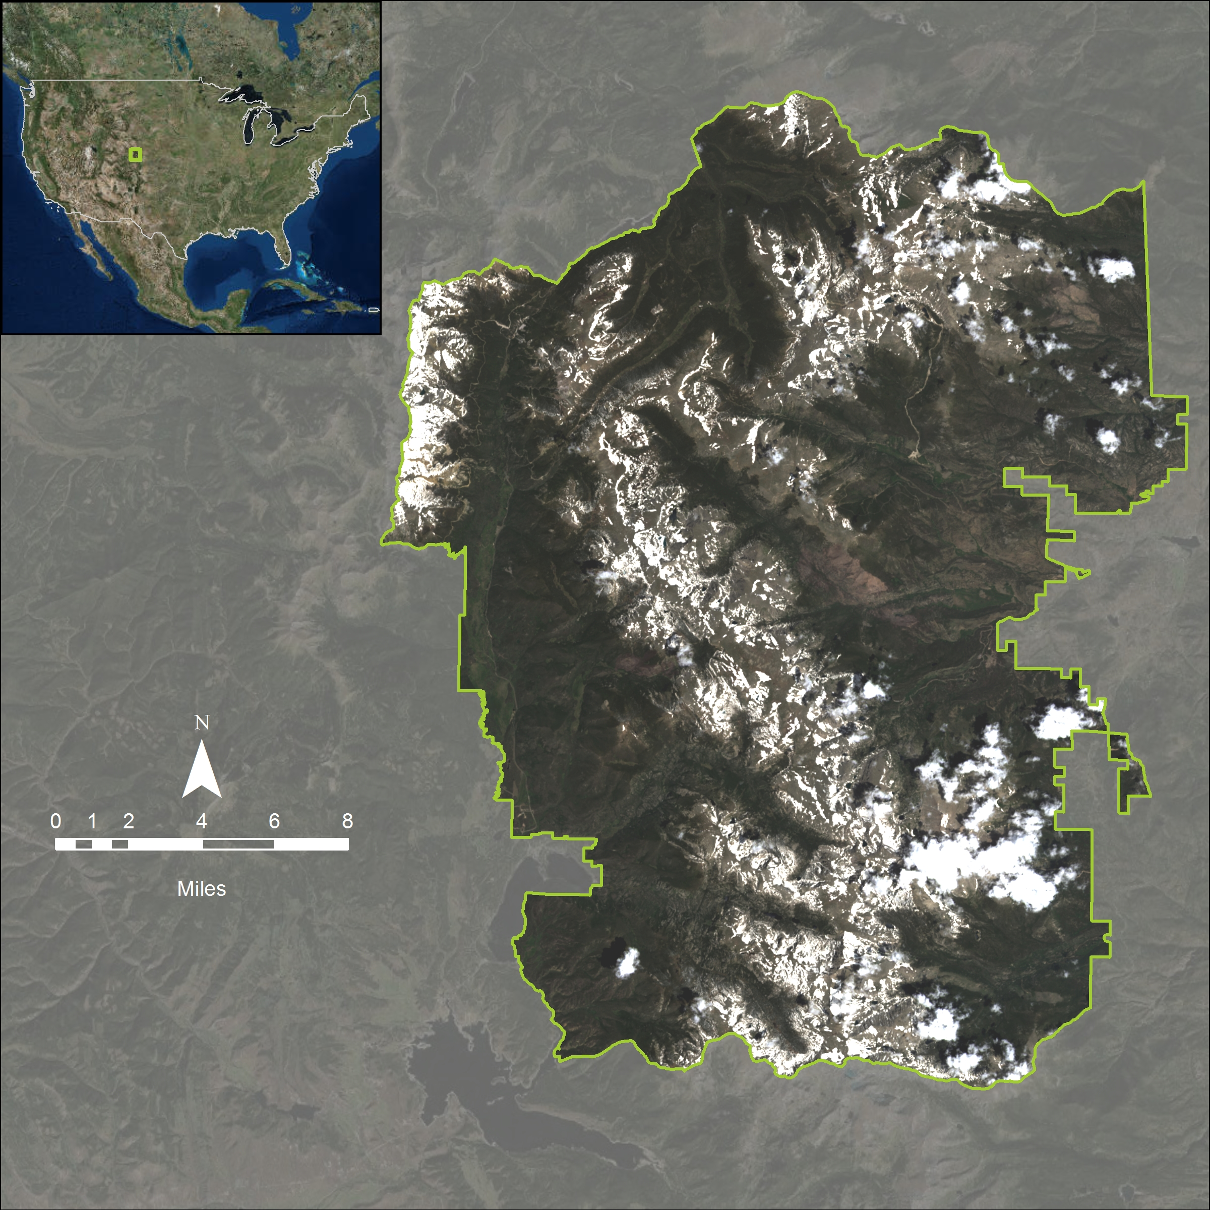

**Figure 1**: Locator Map - The study area is Colorado’s Rocky Mountain National Park.

## 

## 

## **Methods**

Landsat 8 imagery was downloaded from Earth Explorer for July 18th, 2014 and June 21st, 2016. Imagery for the same month had too much cloud cover and was considered unusable, hence the reason that the data chosen was approximately one calendar month apart. Data was also downloaded for June 23rd, 2002 however there appeared to be errors in the imagery and was not used for analysis. The datasets did not undergo radiometric normalization for atmospheric correction due to a lack of the necessary ENVI license, this may result in slight inaccuracies (Meddens et al., 2013). Our analysis was subsetted to the Rocky Mountain National Park boundary as a shapefile downloaded from Data.gov seen in *Figure 1*.

False-color composites were created for each year to demonstrate a clear indication of vegetation health - the healthier the vegetation, the brighter red spectrum appears. A gaussian stretch was applied to both images to clearly visualize the study area to compare the differences in vegetation development as seen in *Figure 2*.

A Normalized Difference Vegetation Index (NDVI) calculation was done for the 2014 and 2016 scenes. NDVI is a method to measure vegetation health by using absorbed red light and reflected near-infrared light (Landsat Forest Area Change Tools, 2015). The formula for NDVI is as follows:

$NDVI=\frac{Near Infrared Band - Red Band}{Near Infrared Band + Red Band}$ (1)

Landsat 8 data uses Band 5 for the Near Infrared and Band 4 for the Red. Bodies of water show values of -1, areas completely lacking in vegetation show low values, 0.1 or less, and the healthier the vegetation the closer values will get to 1 (Remote Sensing Phenology, 2015). ENVI’s Change Detection workflow was done on the 2014 and 2016 NDVI rasters to find “Big Increases” and “Big Decreases” between the two years.

A Normalized Difference Moisture Index (NDMI) calculation was done for the 2014 and 2016 scenes. NDMI is used to monitor droughts and to detect changes in the moisture conditions of vegetation (Landsat Forest Area Change Tools, 2015). The formula for NDMI is as follows:

$NDMI=\frac{Near Infrared Band - Shortwave infrared Band}{Near Infrared Band + Shortwave Infrared Band}$ (2)

Landsat 8 uses Band 6 for the Shortwave Infrared Band. NDMI values from -1 to 0 represent no water content or vegetation, values closer to 1 represent the water content of the pixel (Gao, 1996).

An unsupervised classification was done for both years using 5 classes. This type of classification groups pixels together with common characteristics, without sample sites being selected. This is helpful in determining the land cover types of the most affected areas.

Along with the image analysis techniques in this report, precipitation and temperature data was acquired and analyzed to determine the possible historical reasons for bark beetle damage. This data was found on Colorado State University’s Climate Trends website.

## **Results**

The false-color composites (*Figure 2*), shows the entire RMNP as well as the surrounding area within the Landsat 8 scene. Unfortunately, cloud cover is present throughout both images. This affects the visual demonstration on which image appears to actually have healthier vegetation. As previously mentioned, healthy vegetation is shown in red where it seems that 2016 appears to be brighter than 2014 which may be due to the difference between the two months.

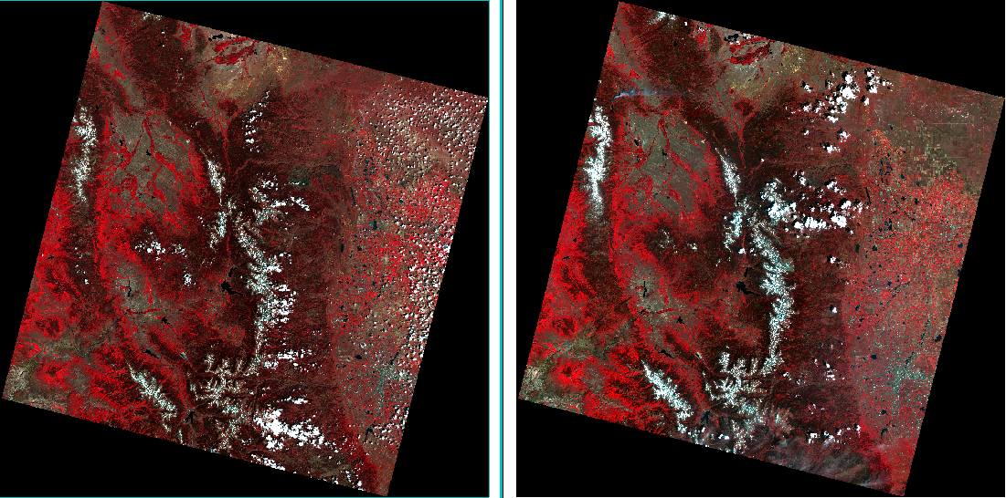

**Figure 2**: False color composite for 2014 on left and 2016 on right.

From 2014 to 2016, the NDVI results showed that 2.8% of the park (7374.168 acres) saw an increase in healthy vegetation and 8.5% of the park (22578.41 acres) saw a decrease in NDVI values. The NDVI for each year is shown in *Figure 3* and the NDVI change detection workflow results are shown in *Figure 4.*

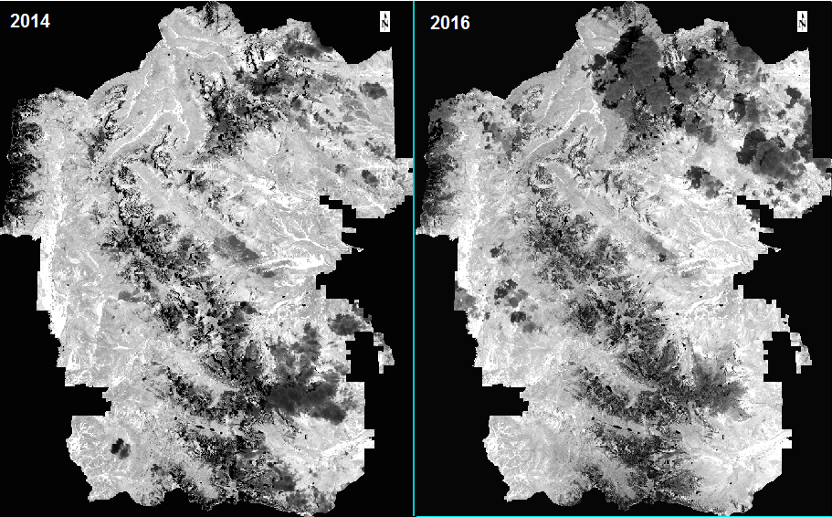

**Figure 3**: NDVI for 2016 on left and 2014 on right.

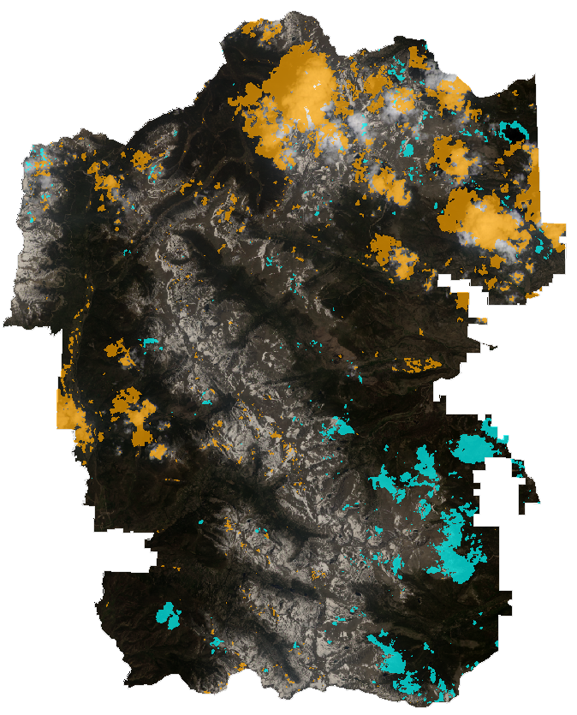

**Figure 4**: Change detection for NDVI 2016 and 2014. Orange shows big decrease in NDVI and blue shows big increase in NDVI.

The NDMI change detection resulted in no areas of increased moisture content, but there was a 97.6% decrease for the park (260318.3 acres) from 2014 to 2016 (*Table 1*). The NDMI for each year is seen in *Figure 5*, the change detection workflow results are seen in *Figure 6.*

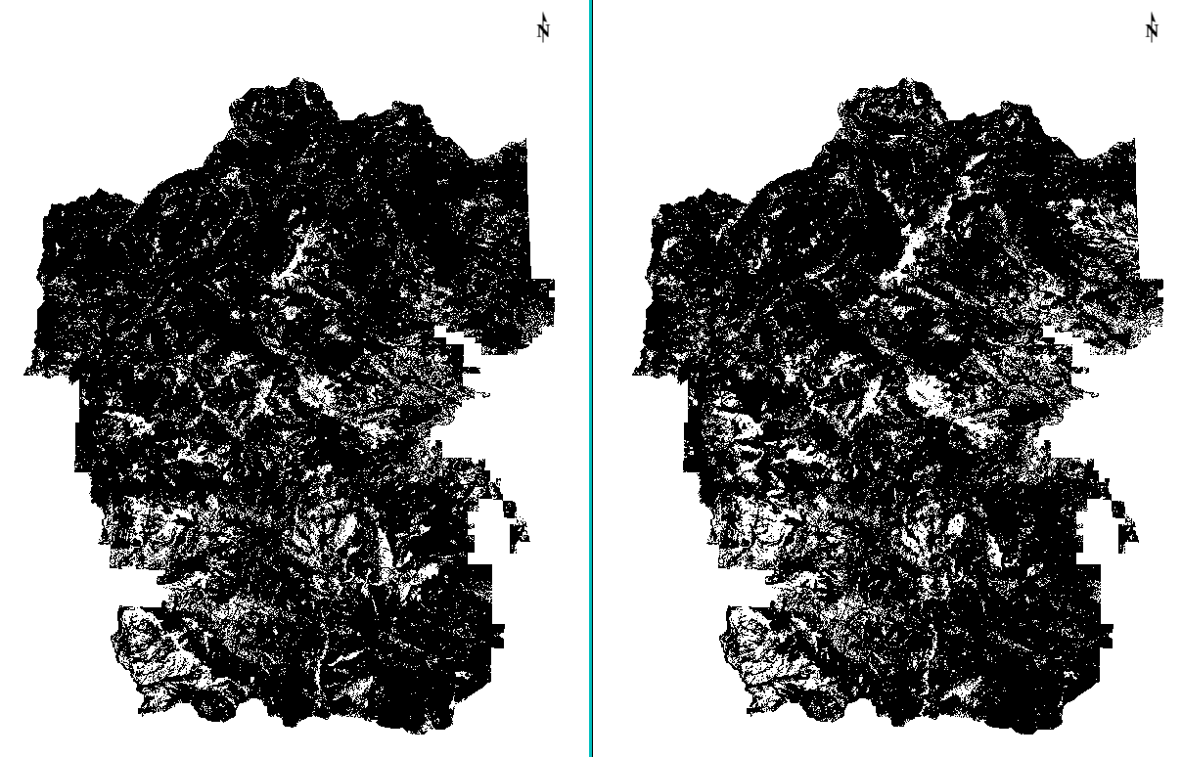

**Figure 5**: NDMI for 2016 on left and 2014 on right.

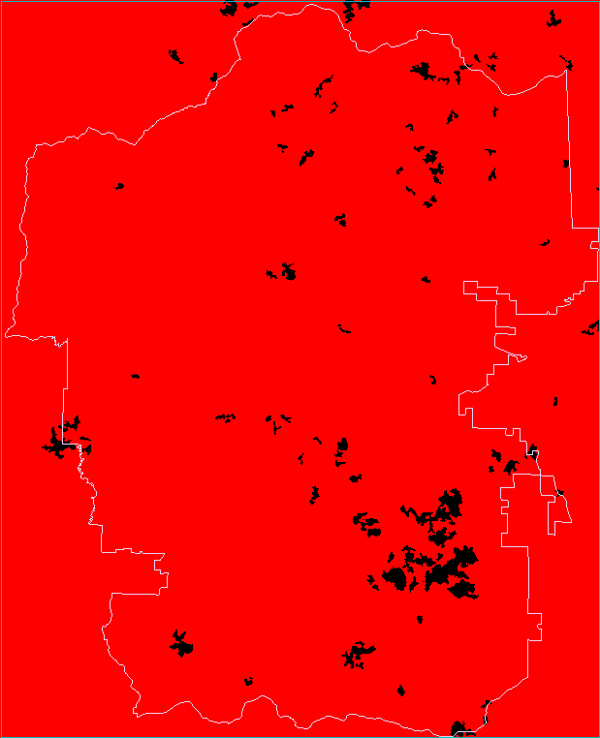

**Figure 6**: Change Detection for NDMI 2016 and 2014. Black represents other and red represents Big Decrease.

**Table 1**: Quantifiable changes of area for NDVI and NDMI.

|  |  |  |
| --- | --- | --- |
|  | **Area in Acres** | **% of total** |
| NDVI |  |  |
| Increase Total: | 7374.168 | 2.8% |
| Decrease Total: | 22578.41 | 8.5% |
| NDMI |  |  |
| Increase Total: | 0 | 0.0% |
| Decrease Total: | 260318.3 | 97.6% |
| RMNP Area | 266726.4 |  |

Both years experienced an unsupervised classification(*Figure 7*) using 5 classes, 3 of them were dominant classes: (1) clouds, cloud shadows, snow, and water in dark blue, (2) less photosynthetic activity and conifers in light blue, and (3) new vegetation, riparian areas, and shrublands in yellow. The other two were; (1) pixels with no values, and (2) mountainous lakes that took up a very small area. Unfortunately, due to licensing issues, there are a fair amount of atmospheric corrections that were unable to be completed. There appears to be an increase in shrublands from 2014 to 2016, and a decrease in conifers. However, in one of the main entrances to RMNP (depicted by the red boxes in *Figure 7*), there appears to be an increase in conifers (light blue). This could be due to an error in classification. It could also be due to the fact that this is where many of the campgrounds are located, and where most of the restoration is taking place. RMNP is spraying high-value trees with insecticides as well as removing already dead or dying trees (Bark beetles - US Forest Service research & development, 2014). This restoration would indeed explain why there is an increase in conifers from 2014 to 2016 in this area compared to the rest of the classification results of the two images.

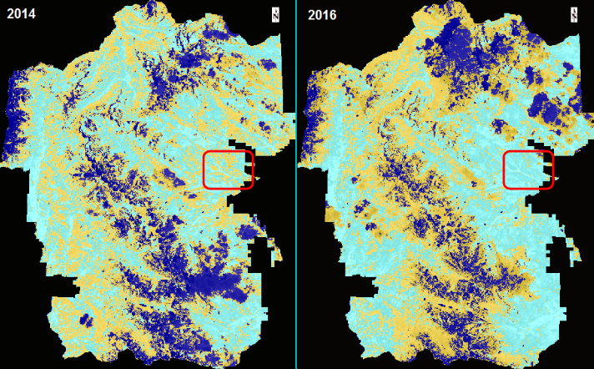

**Figure 7**: Unsupervised Vegetation Classification for 2014 and 2016. Dark blue shows clouds, cloud shadows, snow, and water. Light blue shows less photosynthetic activity and conifers. Yellow shows new vegetation, riparian areas, and shrublands. Red boxes show an area of interest.

RMNP’s data on average annual mean temperature (*Figure 8*) shows higher than average temperature for the late 1990’s and early 2000’s and again in 2014 and 2015. The data for average annual precipitation (*Figure 9*) shows a decrease in precipitation for 2014 and 2015 (Colorado Climate Trends, 2009).

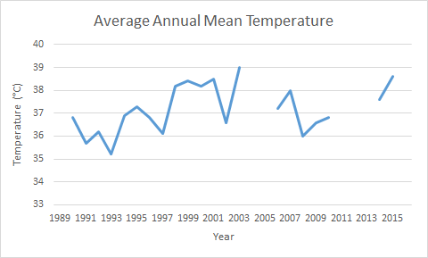

**Figure 8**: Average annual mean temperature for the study area from 1989 to 2015.

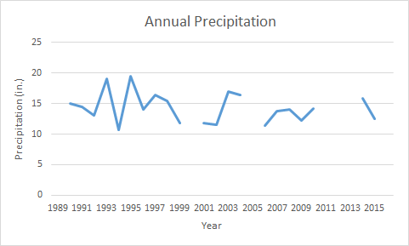

**Figure 9**: Annual precipitation of the study area from 1989 to 2015.

## **Conclusion/Discussion**

The analysis conducted in this investigation determined that the vegetation density is more abundant in 2016 compared to 2014. Despite the decrease in moisture content, bark beetles serve their ecological purpose to allow less competition for broad leaved trees and shrubs to thrive by constant attacks on all conifers. Less competition provided a higher vegetation density overall in the RMNP region. The drastic change in NDMI may be from seasonal snowpack melt, increasing the available water to vegetation and increasing the NDMI value. Further analysis should be done to accurately determine the impact of bark beetle infestation in RMNP region. To improve the accuracy of the NDVI Change Detection analysis (*Figure 4*), atmospheric correction provided by ENVI may have improved our existing results to better reflect our intended purpose. Tassel cap analysis and utilization of LiDAR data is likely the most vital to this area of interest and was not assessed in this project. Ground truthing and supervised classification would prove to be beneficial as well as utilizing emerging Unmanned Aerial Vehicles, or drones, mounted with multispectral cameras to collect data with higher spatial, temporal, and spectral resolution. This study could also encompass a longer time frame and analyze the existing data for earlier years. For ease of analysis it is recommended that a smaller region of interest be selected for any further study.

### 

### 

## **References**

Meddens, Arjan J.h., Jeffrey A. Hicke, Lee A. Vierling, and Andrew T. Hudak. "Evaluating Methods to Detect Bark Beetle-caused Tree Mortality Using Single-date and Multi-date Landsat Imagery." Remote Sensing of Environment 132 (2013): 49-58. Web.

Bark beetle (2016). . In *Wikipedia*. Retrieved from https://en.wikipedia.org/wiki/Bark_beetle

Bark beetles - US Forest Service research & development. (2014, July 28). Retrieved November 2, 2016, from U.S. Forest Service, <http://www.fs.fed.us/research/invasive-species/insects/bark-beetle/>

Bentz, B. J., Regniere, J., Fettig, C. J., Hansen, M. E., Hayes, J. L., Hicke, J. A., … Seybold, S. J. (2010). Climate change and bark beetles of the western United States and Canada: Direct and indirect effects. Retrieved November 2, 2016, from U.S. Forest Service, http://www.treesearch.fs.fed.us/pubs/36133

Gao, Bo-Cai. "NDWI—A Normalized Difference Water Index for Remote Sensing of Vegetation Liquid Water from Space." Remote Sensing of Environment 58.3 (1996): 257-66. Web.

"Landsat Forest Area Change Tools." Project Methods | Landsat Forest Area Change Tools. Southern Group of State Foresters, 2015. Web. 02 Dec. 2016.

Lemonick, M. D. (2013, January 7). Why bark beetles are chewing through U.S. Forests. Retrieved November 2, 2016, from Climate Central, <http://www.climatecentral.org/news/why-bark-beetles-are-chewing-their-way-through-americas-forests-15429>

Negron, J. (2015, September ). Bark beetles: A natural and dramatic forest disturbance | Rocky Mountain research station. Retrieved November 2, 2016, from U.S. Forest Service, <http://www.fs.fed.us/rmrs/projects/bark-beetles-natural-and-dramatic-forest-disturbance>

"Remote Sensing Phenology." Remote Sensing Phenology. U.S.G.S., 12 Jan. 2015. Web. 02 Dec. 2016.

Selected images for six-spined engraver beetle (*Ips sexdentatus*) Retrieved November 3, 2016, from [The University of Georgia](http://www.uga.edu/) - [Warnell School of Forestry and Natural Resources](http://www.forestry.uga.edu/), <http://www.forestryimages.org/collections/viewcollection.cfm?id=51>

Oatman, M. (2015, May/June). Bark Beetles Are Decimating Our Forests. That Might Actually Be a Good Thing. Retrieved November 3, 2016. from Mother Jones, <http://www.motherjones.com/environment/2015/03/bark-pine-beetles-climate-change-diana-six>

Colorado Climate Trends (2009, December). Grand Lake 6 SSW. Retrieved December 2, 2016. from Colorado State University, http://climatetrends.colostate.edu/ct_access?plot=1&station=53500&elem=MNTM&yrbeg=1948&yrend=2016&cyr=0&cyrbeg=1948&cyrend=2016&period=calendar&incomplete=1&debug=0&proc=BOTH

### 